Necessary Background Knowledge

* Basic Linux Commands
  + make, ls, apt-get install …
* An IDE setup
  + I use vim w/ gnu_id-tools

Adding a New Library

I am using Ubuntu as it is user friendly and comes with some default libraries that are useful. In this part I’ll be showing you how I got the main SDL1.2 library up and running.

The first thing you want to do is check if that library is there and what its name is, so that we can install it. Here is the following command to do so:

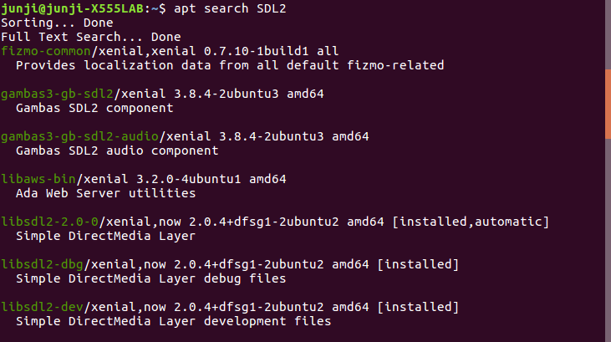

After you find the library you will want to install the development versions as it contains additional information that might be useful when debugging. Voila:



After that make sure the makefile has the appropriate linking instructions for the above example ‘-lsdl2’ should work fine.